
A new generation of DNA hidden repeats detection algorithm
Project Number: 25-2-R-8
Capstone Project Phase B

Fatmeh Zoabi || Email: FatmehZo3bi10@gmail.com
Khalil Mansour || Email: Khalel.Mnsor@e.braude.ac.il
Supervisor: Dr. Zakharia Frenkel

Git: https://github.com/khalelmnsor/A-new-generation-of-DNA-hidden-repeats-detection-algorithm

Contents
1. Background and Problem Overview ................................................................................4
1.1 Biological Significance of Repetitive DNA ...................................................................4
1.2 Characteristics and Detection Challenges of Hidden Repeats ...................................4
1.3 Computational Approaches for Repeat Detection ......................................................4
1.4 Isochores and Large-Scale Genome Organization .......................................................4
1.5 Prior Work on Repeats and Isochore Structure ...........................................................4
1.6 Open Challenges and Research Motivation .................................................................5
2. Description of the Implemented Project .........................................................................5
2.1 General Description .....................................................................................................5
2.2 Description of the Proposed Solution ..........................................................................6
2.2.1 Research and Development Approach ...................................................................6
2.2.2 Structure of the Software and Algorithmic Pipeline ................................................6
2.2.3 Methodological Contribution ................................................................................10
2.3 Description of the Research and Development Process ...........................................10
2.3.1 Research Methodology and Algorithm Development ...........................................10
2.3.2 Data Usage and Experimental Scope ....................................................................10
2.4 Implementation Tools and Development Environment .............................................11
2.5 Challenges, Solutions and results .............................................................................11
2.5.1 Key Challenges in Hidden DNA Repeat Detection ................................................11
2.5.2 Solutions and Decision-Making ............................................................................12
2.5.3 Results ..................................................................................................................13
2.5.4 Conclusions ..........................................................................................................19
2.6 Lessons Learned ........................................................................................................19
2.7 Project Goals and Success Evaluation ......................................................................19
2.7.1 Evaluation Against Project Objectives ..................................................................19
2.7.2 Success Metrics and Unexpected Outcomes .......................................................20
2.7.3 Limitations and Future Improvements ..................................................................20
2.7.4 Summary ...............................................................................................................20
3. User Guide – Operating Instructions .............................................................................21
3.1 Purpose of the User Guide .........................................................................................21
3.2 Intended Users ...........................................................................................................21
3.3 System Overview .......................................................................................................21
3.4 Input Requirements ...................................................................................................21
3.4.1 DNA Sequence Input .............................................................................................21
3.4.2 Algorithm Parameters ...........................................................................................21
3.5 Nominal Operating Procedure (Successful Flow) .....................................................22
3.6 Output Description ....................................................................................................22
3.7 Usage Scenarios ........................................................................................................23
3.8 Notes and Limitations ................................................................................................23
3.9 Summary ...................................................................................................................23

4. Maintenance Guide .......................................................................................................24
4.1 Purpose of the Maintenance Guide ............................................................................24
4.2 Scope of Maintenance ...............................................................................................24
4.3 System Operating Environment .................................................................................24
4.3.1 Software Environment ..........................................................................................24
4.3.2 Hardware Environment .........................................................................................24
4.4 Structure of the Custom Software .............................................................................25
4.5 Applying Changes and Updates .................................................................................25
4.5.1 Algorithmic Parameter Updates ............................................................................25
4.5.2 Algorithm Extension ..............................................................................................25
4.6 Supporting Long-Term System Use ............................................................................25
4.7 Limitations and Maintenance Considerations ...........................................................25
4.8 Summary ...................................................................................................................26

5. References ....................................................................................................................26

1. Background and Problem Overview
1.1 Biological Significance of Repetitive DNA
Advances in genomics have revealed that repetitive DNA sequences play a fundamental role in genome organization, regulation, and genome dynamics. Once considered “junk DNA,” repetitive elements are now known to influence chromatin structure, gene regulation, replication timing, and genome stability. Abnormal expansions of repetitive sequences have been linked to a variety of diseases, including cancer and neurological disorders. Despite their importance, many repetitive structures - particularly hidden or low-complexity repeats - remain difficult to detect due to their subtle statistical signatures and structural variability.
1.2 Characteristics and Detection Challenges of Hidden Repeats
Hidden DNA repeats are characterized by weak sequence similarity, sequence variations (substitutions/indels), rearrangements, and low compositional complexity. These properties limit the effectiveness of traditional alignment-based and motif-search methods, especially when repeats are nested or distributed across non-contiguous genomic regions. As genomic datasets continue to grow in size and complexity, there is an increasing need for sensitive computational approaches capable of detecting not only known repeat families but also previously uncharacterized or cryptic repetitive patterns.
1.3 Computational Approaches for Repeat Detection
To address these challenges, a wide range of advanced computational techniques have been proposed. Statistical models leverage probabilistic frameworks to identify repeats under sequence variability, while machine learning approaches use trained classifiers to distinguish repetitive from non-repetitive regions.
Hidden Markov Models (HMMs) have proven effective for uncovering cryptic and nested repeats by modelling hidden sequence states.
Graph-theoretical approaches, including De Bruijn graphs and spectral methods, enable the detection of complex repeat structures through network representations and frequency-domain analysis.
In addition, segmentation-based techniques divide genomic sequences into homogeneous regions, improving the resolution and sensitivity of repeat detection by isolating structurally coherent segments.
1.4 Isochores and Large-Scale Genome Organization
Parallel to repeat research, the study of isochores - large genomic regions characterized by relatively uniform GC content - has provided key insights into genome organization. Isochores are associated with gene density, chromatin structure, and functional genomic domains.
1.5 Prior Work on Repeats and Isochore Structure
Previous studies have suggested a structural relationship between repetitive elements and isochore organization, indicating that repeats may contribute to the formation and maintenance of GC-homogeneous regions. Accurate detection of isochores typically relies on segmentation algorithms that identify GC-content transitions across large genomic scales.
Foundational work by Frenkel, Trifonov, and collaborators demonstrated that hidden triplet-based repeats are widespread in genomes and may result from large-scale compositional and structural sequence processes. Their dynamic programming–based segmentation approach revealed that a significant fraction of genomic sequences can be explained by embedded repeat expansions, supporting a modular view of genome architecture.
A subsequent study proposed an algorithm for detecting hidden repeats and reported a correlation between repeat segment scores and GC content, suggesting a potential link between repeat structure and isochore organization. Unexpectedly, additional correlations involving purine composition were observed, raising questions regarding the statistical robustness and biological interpretation of these findings.
1.6 Open Challenges and Research Motivation
Despite these advances, several open challenges remain. Existing methods often lack rigorous statistical significance estimation for detected repeats, may suffer from over-fragmentation, or are limited in their ability to generalize across multiple genomes. Furthermore, the precise structural relationship between hidden repeats and isochores has not been fully validated, particularly across diverse species and larger datasets.
This project addresses these challenges by refining a segmentation-based hidden repeat detection algorithm through hierarchical merging, dominant k-mer analysis, and statistical noise filtering. By incorporating P-value based segment reliability estimation and extending the analysis to multiple genomes, the study aims to provide a more robust and scalable framework for detecting hidden repeats and for systematically examining their association with isochore structures. The resulting approach seeks to improve both detection accuracy and biological interpretability, contributing to a deeper understanding of genome organization.
2. Description of the Implemented Project
2.1 General Description
This project is a research-oriented computational study aimed at improving the detection of hidden repeat structures in DNA sequences and at examining their relationship with large-scale genomic organization, particularly isochore structures. The primary objective of the system is not to serve as an end-user application, but rather to provide a theoretical and algorithmic framework that enables accurate, scalable, and statistically reliable identification of subtle repetitive patterns in genomic data.
The system operates by analyzing DNA sequences at the level of fixed-length segments and extracting compositional regularities using k-mer statistics. By combining segmentation, dominant k-mer analysis, and statistical significance testing, the proposed framework identifies repeat regions that are difficult to detect using traditional alignment-based methods. A key design goal of the system is to balance high sensitivity to hidden repeats with computational efficiency, allowing the analysis of long genomic sequences and multiple genomes.
The target users of the proposed system are bioinformatics researchers, computational biologists, and genomics researchers interested in genome structure, repeat biology, and sequence composition analysis. The system is intended as a research-oriented analytical tool, generating statistically validated repeat segments with interpretable consensus representations and segment-level significance measures.
2.2 Description of the Proposed Solution
2.2.1 Research and Development Approach
The proposed solution follows a research-driven development approach, grounded in prior theoretical work on segmentation algorithms and hidden repeat detection. The algorithm adapts principles from efficient text segmentation methods- specifically the linear-time segmentation approach of Kern and Granitzer (2009)-to the domain of genomic sequence analysis. This adaptation enables the division of long DNA sequences into coherent, fixed-length segments, allowing localized analysis without relying on explicit sequence alignment.
The core idea underlying the solution is that hidden DNA repeats manifest as statistical regularities in k-mer composition within local genomic regions. These regularities can be captured by analyzing positional nucleotide frequencies within k-mers and by identifying a dominant representative (consensus) word for each segment. By combining segmentation with statistical evaluation, the proposed approach enables robust detection of weak and imperfect repeat structures that are often missed by classical methods.

2.2.2 Structure of the Software and Algorithmic Pipeline
The system is structured as a sequential analytical pipeline consisting of the following main stages:
- Input A DNA sequence
The input to the system is a DNA sequence composed of valid nucleotides (A, C, G, T). Several fixed parameters control the behaviour of the algorithm, including the segment length, a set of candidate word lengths, the maximum number of allowed mismatches, the window size used for the null model.
$$S= s_{1 }s_{2 }.. s_{N }, s_{i }∈\left\{A, C, G,T\right\}$$
Fixed parameters:
- Segment length: L
- Candidate word lengths: $K ∈ \left\{3, 4 , 5, 6,…\right\}$
- Allowed mismatches: M = 1
- Null-model window size: W
- DNA Segmentation
The DNA sequence is scanned left-to-right and divided into non-overlapping segments of length. Only valid nucleotides (A, C, G, T) are retained.
Formally:
$$S→\left\{S_{1 }{,S}_{2 },…{,S}_{m }\right\}$$
Where each segment has a length L.
Each segment is processed independently.
- Word Decomposition inside a Segment
For a fixed S_{i} segment and candidate word length K :
- The segment is split into non-overlapping k-mers:
$S_{i }= w_{1 }{,w}_{2 },…{,w}_{n }$
Where:
$n= \left\lfloor \frac{{|S}_{i }|}{K}\right\rfloor$
These k-mers define the basic repeat units.
- Representative Word with Mismatches
Objective:
Detect a consensus repeat word robust to sequence changes.
Method:
For each candidate k-mer appearing in the segment:
$$support\left(c\right)=\#\left\{w_{j }:Hamming\left(w_{j },c\right)≤M\right\}$$
The representative word is selected as:
$$w^{*}=arg \max_{c}{ support(c} )$$
This allows detection of mutated or weak repeats.

- AVG Match Score
For representative word $w^{*}$of length K, define:
$$AVG\left(K\right)=100 ∙ \frac{\sum_{j=1}^{n}{\sum_{p=1}^{K}{1\left[w_{j }\left[pK^{*}\right] = w^{*}\left[p\right]\right]}}}{nK}$$
This measures average positional agreement between the segment and the representative word.

- Selection of Word Length (Two Pipelines)
6.1 AVG-Based Pipeline
For each K:
- Compute $w^{*}$(K) ( Representative Word with Mismatches)
- Compute $AVG$(K) (AVG Match Score For representative word $w^{*}$)
Select:
$K^{*}=arg⁡\max_{k}{ AVG(K} )$
This pipeline favors smooth, high-consensus patterns.

6.2 P-Value-Based Pipeline
For each K:
- Compute representative word
- Build positional counts
- Compute combined statistical significance
Select:
$K^{*}=arg \min_{k}{ P(K} )$
This pipeline favors statistically significant periodic structure.
- Positional Count Matrix
For selected $K^{*}$, build:
$$C\left[p,x\right]=\#\left\{j : w_{j }\left[p\right]= x\right\}, x∈\left\{A, C, G,T\right\}$$
- Positional Binomial P-Values
For each position p:
- Let $k_{p}= \max_{x} C\left[p, x\right]$
- Let n be the number of k-mers

Assuming a random DNA model:
$$X_{p}\sim Binomial\left(n, 0.25\right), \\ B=P(X≥k)$$

The positional p-value is:
$${P=1-\left(1-B\right)}^{4}$$
No multiplication by 4 is applied; each position is evaluated independently.

- Fisher Combination
Combine positional p-values:
$$X=-2 \sum_{P=1}^{K^{*}}{ln⁡(p_{p})}$$
Under the null hypothesis:
$$X \sim χ_{2K^{*}}^{2}$$
The segment-level p-value is:
$$P_{segment}= P\left(χ_{2K^{*}}^{2}≥ X \right)$$

- Composition-Preserving Null Model
Statistical significance of detected repeat patterns cannot be reliably assessed using a naïve random DNA background with uniform nucleotide probabilities. Real genomic sequences exhibit strong and spatially varying compositional biases, such as GC-content fluctuations and isochore-like structures, which alone can produce apparent positional nucleotide enrichments. If such compositional effects are not controlled for, purely random periodic signals may be incorrectly classified as biologically meaningful repeats.
To address this issue, we employ a composition-preserving null model that explicitly maintains the local nucleotide composition of the original genome while destroying higher-order repeat structure. This enables a fair and conservative comparison between real genomic segments and a background model that reflects realistic compositional constraints.

Local Composition Estimation via Sliding Window
Given the original DNA sequence S=s1,s2,…,sn a local nucleotide distribution is estimated independently for each genomic position using a sliding window of radius W.
For a given position i, the window covers the interval:
[i−W,i+W]
clipped to valid sequence boundaries. Within this window, the counts of nucleotides A,C,G,T are accumulated:
$$cntb​(i)=\#\{sj​=b∣j∈[i-W,i+W]\},b∈\{A,C,G,T\}$$
To prevent zero-probability artifacts and stabilize estimation in small windows, pseudocount smoothing is applied with a fixed constant α=1. The resulting local probabilities are:
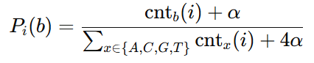
This produces a position-specific multinomial distribution that reflects the local compositional context of the genome.

Random Sequence Generation
A null DNA sequence Snull of identical length to the original genome is generated sequentially. At each position i, a nucleotide is sampled independently according to the locally estimated distribution Pi ​.
Formally:
$$si​∼Categorical\left(Pi​\left(A\right),Pi​\left(C\right),Pi​\left(G\right),Pi​\left(T\right)\right)$$
Importantly, the sliding window statistics are computed from the original genome, not from the partially generated null sequence. This ensures that the null model preserves the same large-scale compositional trends as the real genome, including gradual GC-content variation, while eliminating any true repeat or periodic structure.
- Segment Strength Scoring
For each segment:
$$strengthScore= \frac{max⁡(P_{null}, ε)}{max⁡(P_{real}, ε)}$$
Classification:
- Strong: score ≥ 10
- Weak: 1 < score < 10
- Noise: score ≤ 1

- Final Output
Each segment is annotated with:
- Representative word
- Word length
- AVG score
- Combined p-value
- Strength classification…..
This completes the algorithmic framework.

2.2.3 Methodological Contribution
This work introduces a segmentation-based statistical framework for detecting hidden and weak DNA repeats in genomic sequences. The proposed method combines consensus repeat-words with mismatch tolerance and position-wise statistical validation, enabling improved sensitivity to imperfect periodic structures that are often missed by classical approaches. A dual word-length selection strategy, based on either consensus strength or statistical significance, provides flexibility in identifying repeat periods. The integration of a composition-preserving null model and canonical rotational alignment ensures fair comparison, interpretability, and consistency across segments. Overall, the methodology offers a scalable, interpretable, and statistically grounded approach to hidden DNA repeat detection.
2.3 Description of the Research and Development Process
This project followed a research-driven development process, combining theoretical adaptation, algorithmic refinement, and large-scale genomic experimentation. The overall goal of the process was to design, implement, and validate a statistically robust segmentation-based algorithm for detecting hidden repeats in DNA sequences, while maintaining computational efficiency and biological relevance.
2.3.1 Research Methodology and Algorithm Development
The research began with the conceptual adaptation of a linear-time text segmentation algorithm proposed by Kern and Granitzer (2009) to the domain of genomic sequence analysis. The core idea was to draw an analogy between textual coherence and genomic compositional homogeneity. While text segmentation aims to identify thematic boundaries between sentences, the adapted approach aims to detect biologically meaningful regions in DNA based on k-mer composition and statistical regularity.
The algorithm development proceeded iteratively. An initial segmentation framework based on fixed-size DNA segments was implemented, followed by the integration of dominant k-mer extraction and similarity-based merging rules. Subsequent stages focused on enhancing the reliability of segmentation decisions through the incorporation of statistical significance testing. In particular, binomial tests were introduced to evaluate whether observed nucleotide dominance patterns could arise by chance, and Fisher’s method was used to combine multiple positional P-values into a single segment-level significance score.
Throughout the development process, emphasis was placed on refining the merging logic to reduce over-fragmentation while preserving true biological signals. Intermediate segments disrupting repetitive patterns were systematically evaluated as potential noise, allowing statistically insignificant regions to be merged across stronger neighbouring segments.
2.3.2 Data Usage and Experimental Scope
The algorithm was evaluated using a single human chromosome as the experimental dataset. The analysis was conducted on the full DNA sequence of this chromosome, allowing detailed examination of repeat structures within a large, contiguous genomic region.
No biological preprocessing steps were applied in order to preserve the natural characteristics of the sequence. The only preprocessing operation performed was the removal of non-standard nucleotide symbols (e.g., ambiguous characters), ensuring that the input consisted exclusively of valid DNA bases (A, C, G, T).
The choice to focus on a single chromosome enabled controlled evaluation of the algorithm’s behavior on real genomic data while maintaining computational feasibility.
2.4 Implementation Tools and Development Environment
The core algorithm was implemented in C++, enabling efficient processing of large genomic datasets. Development was carried out using Visual Studio Code as the primary programming environment. The choice of C++ was motivated by performance considerations, particularly the need to support linear-time processing and memory-efficient handling of long DNA sequences.
In addition, Python was used for auxiliary tasks, including experimental analysis, result inspection, and data handling. This combination allowed performance-critical components to be implemented in C++ while leveraging Python’s flexibility for supporting experimentation and analysis workflows.
2.5 Challenges, Solutions and Results
2.5.1 Key Challenges in Hidden DNA Repeat Detection
Detecting hidden DNA repeats in real genomic sequences involves several inherent challenges:
- Weak or mutated repeats
Repeat instances are often partially altered or degraded over long genomic timescales, making them difficult to detect using exact matching or alignment-based methods.
- Unknown repeat period
The true periodicity of repeats is typically not known in advance, requiring the algorithm to infer the repeat length directly from the sequence.
- Varying sequence composition
Local compositional biases in DNA sequences can create repeat-like patterns that do not correspond to true biological repeats, complicating reliable detection.
- Random false positives
Random nucleotide arrangements may appear periodic by chance, especially when analyzing long sequences, leading to spurious detections.
- Genome-scale scalability
Whole-genome analysis requires algorithms that are both computationally efficient and capable of handling very long sequences without loss of local sensitivity.

2.5.2 Solutions and Decision-Making
The design of the proposed algorithm directly addresses these challenges through the following decisions:
- Consensus repeat-words with mismatches
To handle weak and mutated repeats, the algorithm detects consensus repeat-words while allowing a limited number of mismatches, enabling robust identification of imperfect periodic structures.
- Testing multiple candidate periods
Unknown repeat periods are addressed by evaluating multiple candidate word lengths and selecting the most representative one based on consensus strength or statistical significance.
- Composition-preserving null model
To reduce artifacts caused by local sequence composition, a composition-preserving null model is used, ensuring fair comparison between real and randomized sequences.
- Statistical significance testing
Positional binomial tests combined using Fisher’s method are applied to distinguish meaningful repeat signal from random background noise and reduce false positives.
- Segment-based processing for scalability
The DNA sequence is analyzed using fixed-length segments, enabling efficient and scalable genome-wide analysis while maintaining local structural resolution.

2.5.3 Result
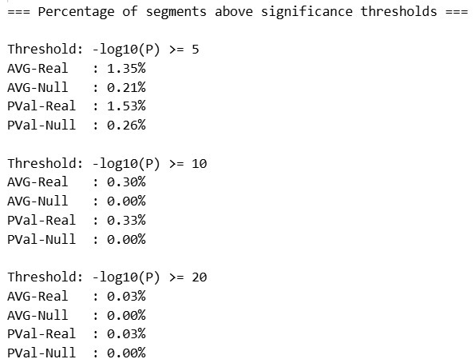
Figure 1: Output of the percentage of segments above significance thresholds
Significance Threshold Analysis
The proportion of segments exceeding selected statistical thresholds provides a quantitative measure of algorithm specificity.
For moderate significance thresholds (−log10(P) ≥ 5), real genomic data consistently produces a higher fraction of significant segments compared to null sequences. This confirms that the algorithm detects repeat structures enriched beyond random expectations.
For higher thresholds (−log10(P) ≥ 10 and ≥ 20), both datasets exhibit extremely low proportions of significant segments. This observation indicates that strongly conserved periodic repeats represent rare but highly reliable genomic features.

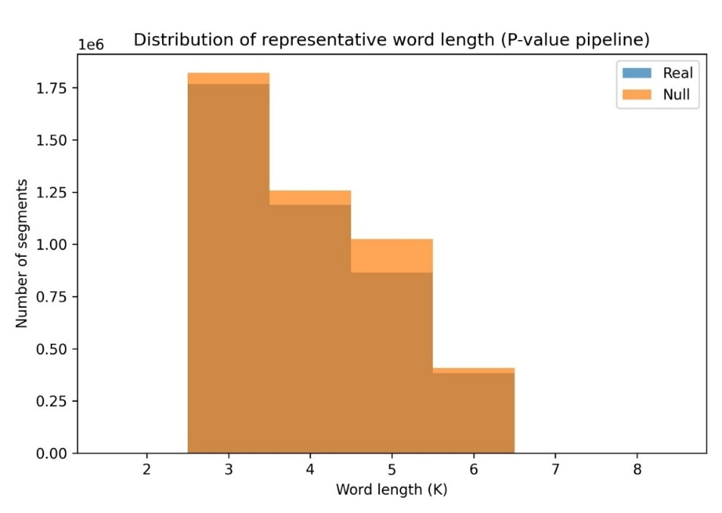
Figure 2: P-value pipeline - Distribution of representative word length
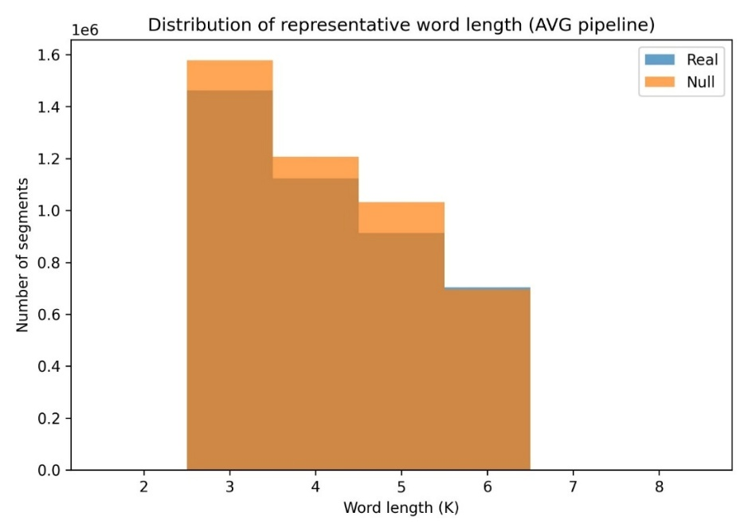
Figure 3: AVG pipeline - Distribution of representative word length

Representative Word Length Distribution
Analysis of representative word length (K) reveals that most selected repeat periods fall within the range of 3 to 6 nucleotides.
This result aligns with biological expectations, as trinucleotide periodicity is strongly associated with codon structure in protein-coding regions. The presence of dominant periodicities in this range suggests that the algorithm successfully captures coding-related repeat organization as well as other short-period genomic motifs.
The similarity between real and null K distributions indicates that periodic length selection is primarily determined by algorithmic structure and segment size constraints, while statistical significance analysis is required to differentiate biologically meaningful repeats from random periodic patterns.

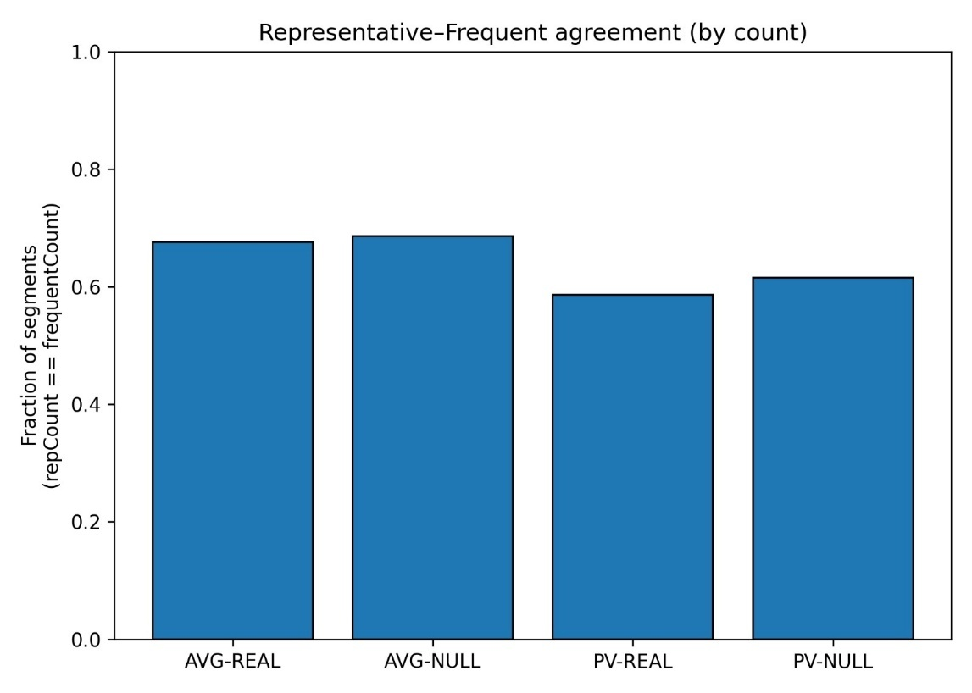
Figure 4: Representative-frequent agreement - by count
Representative Word vs Most Frequent Word Agreement
This experiment evaluates the consistency between two different repeat characterization strategies:
- Representative word selected using mismatch-tolerant consensus optimization
- Most frequent k-mer determined by raw frequency counts
The agreement rate ranges between approximately 60% and 70% across pipelines. This partial agreement demonstrates that consensus-based repeat representation captures biologically meaningful patterns that are not necessarily the most frequent exact k-mer.
This finding is particularly important in genomic analysis because sequence changes often distort repeat copies, causing the biologically relevant consensus motif to differ from the most frequent exact substring. Therefore, mismatch-aware consensus selection improves robustness to sequence variation.

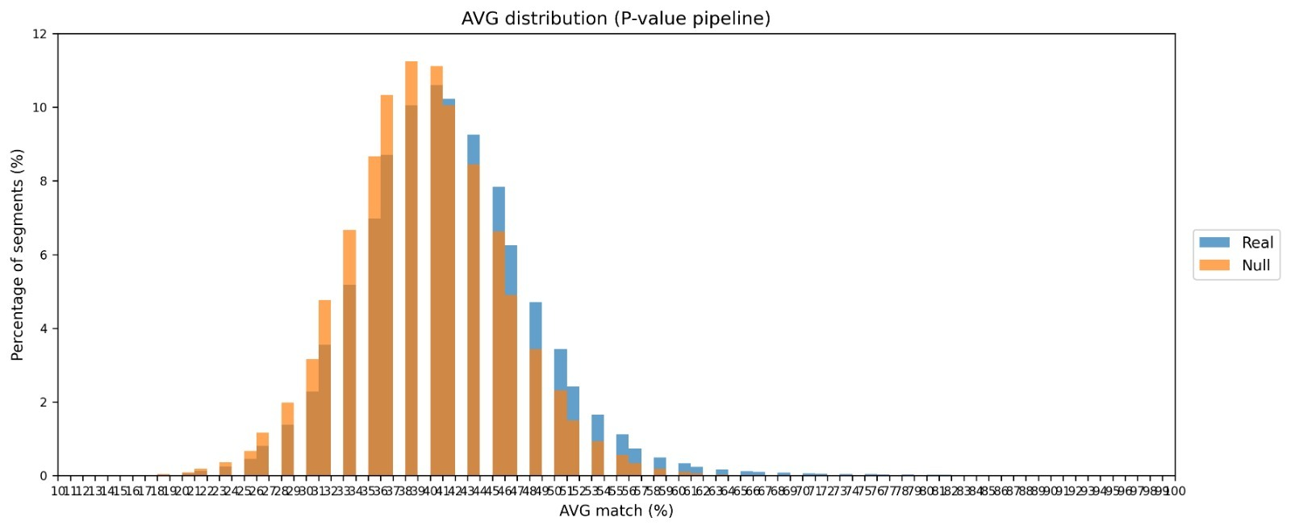
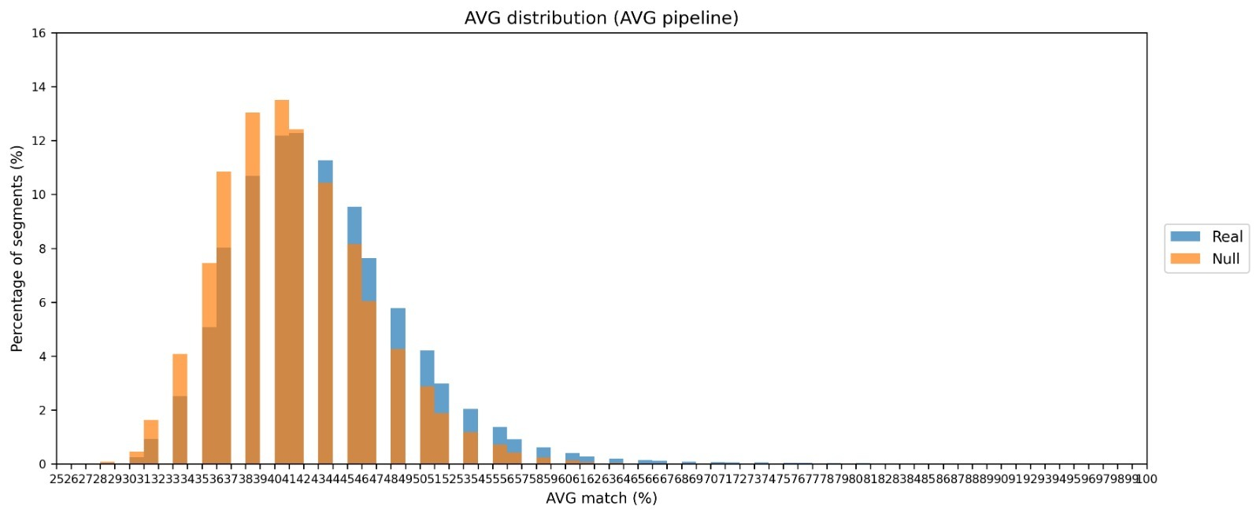
Figure 5: P-value pipeline - AVG distribution
Figure 6: AVG pipeline - AVG distribution

Average Positional Match Distribution
The AVG score measures the average positional agreement between segment k-mers and the representative consensus word.
The distribution analysis shows that real genomic segments tend to achieve slightly higher AVG values compared to null sequences. This result suggests that real DNA contains structured repetitive motifs exhibiting consistent nucleotide alignment across periodic positions.
Nevertheless, the overlap between real and null distributions indicates that hidden repeats frequently include mutation noise and partial motif conservation, rather than perfect tandem duplication. This observation supports the biological relevance of allowing mismatch-tolerant repeat detection.
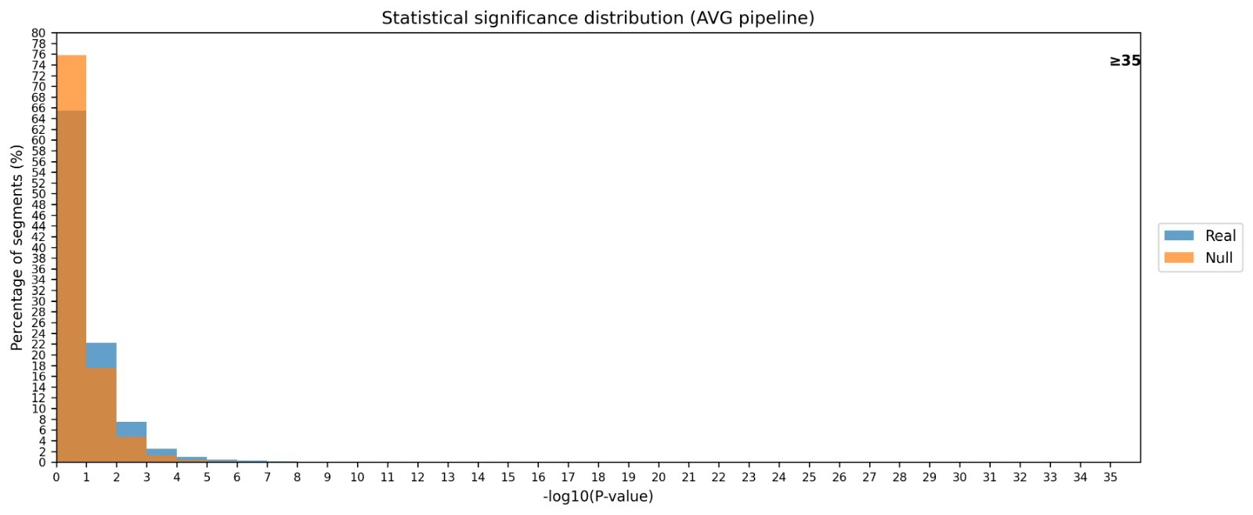
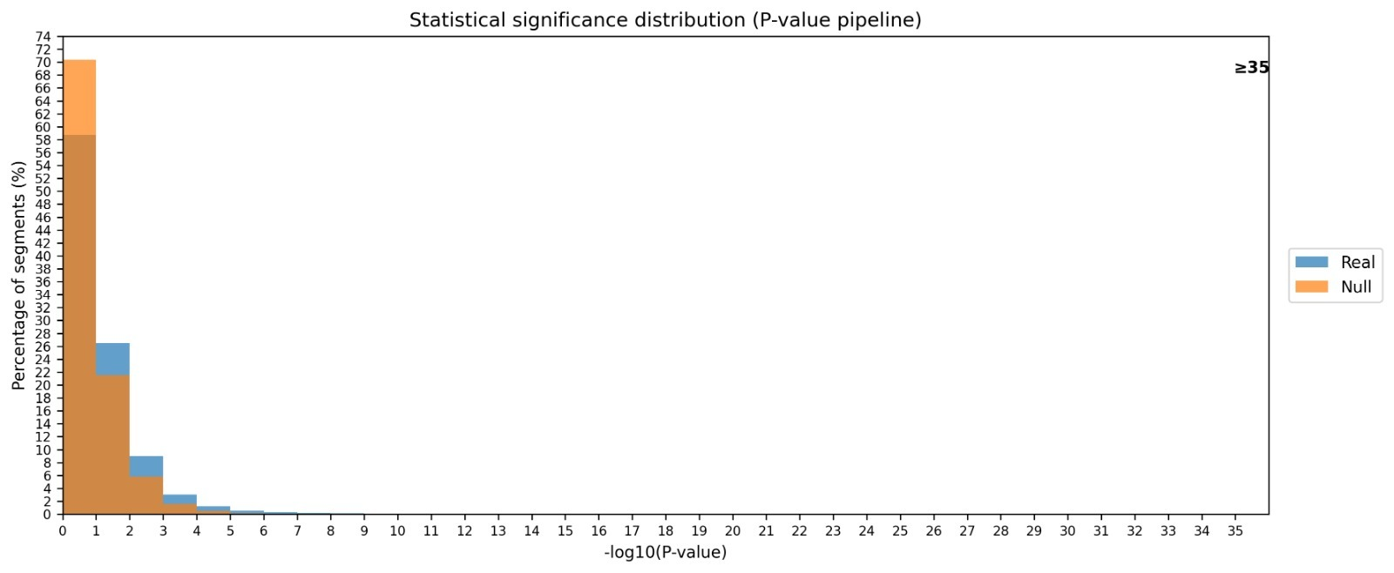
Figure 8: AVG pipeline - Statistical siginficance distibution
Figure 7: P-value pipeline - Statistical significance distribution

Distribution of Statistical Significance Values
Histograms of −log10(P-values) further illustrate the statistical strength of detected repeat segments.
Both pipelines show that the majority of segments fall within low significance ranges (−log10(P) between 0 and 3). This observation is consistent with known genomic structure, where strong tandem repeats represent only a small fraction of total genomic sequence.
However, the P-value pipeline demonstrates a slightly heavier tail toward higher significance values compared to the AVG pipeline. This indicates improved sensitivity for detecting strongly conserved repeat patterns.
Importantly, the null distributions remain concentrated in low significance regions, confirming that highly significant segments detected in real genomic data are unlikely to arise from nucleotide composition bias alone.
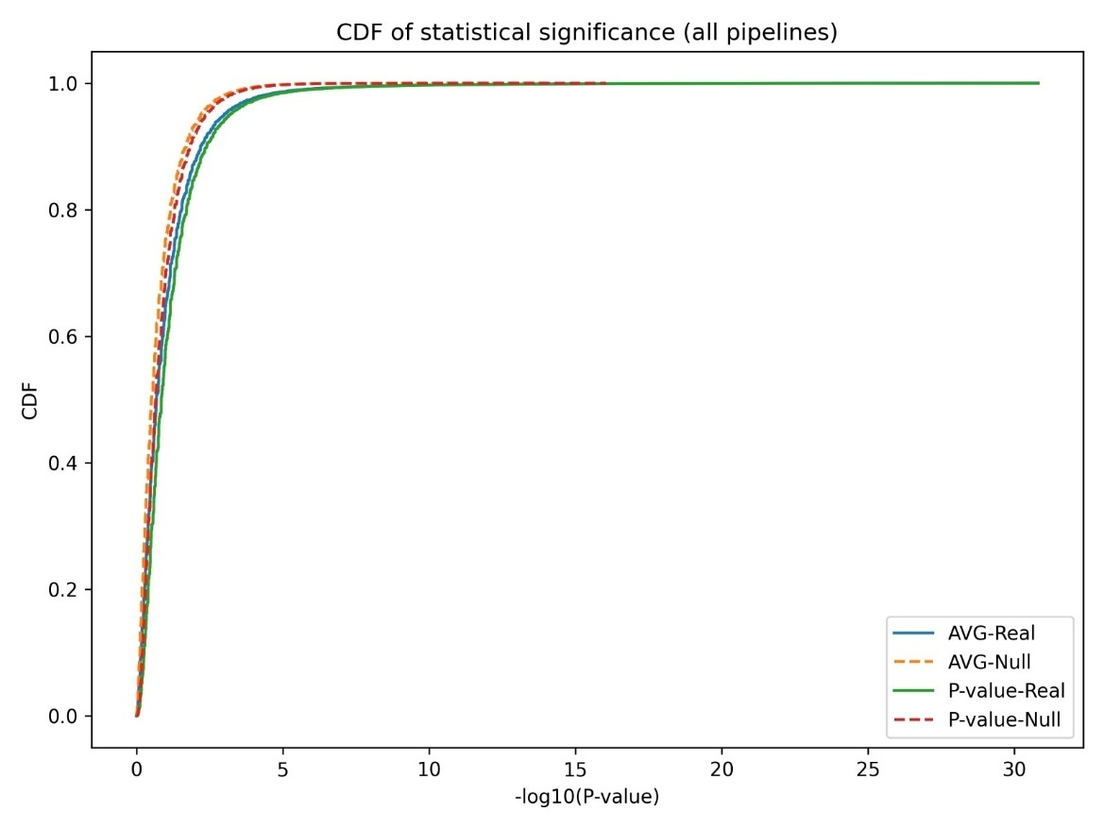
Figure 9: All pipelines - CDF of statistical significance

Cumulative Distribution of Statistical Significance
The cumulative distribution function (CDF) of −log10(P-value) provides a global view of the statistical strength of detected repeat segments across both pipelines and both datasets (real genomic sequences and composition-preserving null sequences).
The CDF curves demonstrate that, for both detection pipelines, the distributions corresponding to real genomic sequences are consistently shifted toward higher statistical significance compared to the null model. This shift indicates that the segmentation algorithm detects structured repeat patterns that occur more frequently in real DNA than would be expected under a randomized sequence model preserving local nucleotide composition.
Furthermore, comparison between the AVG-based pipeline and the P-value-based pipeline reveals that the statistical pipeline produces slightly stronger significance enrichment. This behavior is expected because the P-value selection strategy directly optimizes statistical deviation from random nucleotide distribution, whereas the AVG pipeline primarily optimizes positional similarity without explicitly modeling stochastic expectations.
Overall, the separation between real and null distributions confirms that the algorithm captures biologically meaningful repetitive signals rather than random sequence noise.

2.5.4 Conclusions
The experimental evaluation demonstrates that the proposed segmentation-based hidden repeat detection algorithm successfully distinguishes structured genomic periodicity from composition-preserving random sequences.
The results confirm several key properties:
  - The algorithm detects biologically meaningful repeat signals rather than random noise
  - Statistical selection improves detection specificity compared to purely similarity-based scoring
  - Mismatch-tolerant consensus representation provides robustness against sequence variability
  - Detected repeat periods align with biologically expected genomic periodicities
Collectively, these findings validate the effectiveness of the algorithm for large-scale genomic repeat characterization and support its application in isochore and genome organization studies.
2.6 Lessons Learned
Several important lessons emerged from this research:
- Statistical validation is essential for reliable biological interpretation; heuristic-only approaches are insufficient for complex genomic patterns.
- Treating segmentation noise explicitly, rather than ignoring it, leads to more stable and biologically meaningful results.
- Iterative refinement is critical in research-oriented algorithm development, especially when theory and biological interpretation intersect.
2.7 Project Goals and Success Evaluation
2.7.1 Evaluation Against Project Objectives
The project objectives defined in Phase A were largely achieved, with the core methodological goals successfully implemented and validated. The algorithm was refined into a segmentation-based statistical framework capable of detecting hidden and weak DNA repeats that are often missed by classical methods. Throughout the development process, several design decisions were adjusted to improve robustness and interpretability, particularly in the use of consensus repeat-words and statistical significance testing at the segment level.
During development, the scope of the project was intentionally refined. Rather than focusing on explicit biological validation of GC content or isochore structure, the work concentrated on establishing a sound and reliable algorithmic foundation for hidden repeat detection. This change ensured that the project goals remained feasible within the available time and computational resources, while preserving scientific validity.
Some originally envisioned objectives-such as adaptive segmentation lengths and advanced segment merging strategies-were not fully implemented and are therefore identified as future extensions rather than completed goals.

2.7.2 Success Metrics and Unexpected Outcomes
Project success was defined internally according to the following criteria:
- Reliable detection of hidden and imperfect DNA repeats using a statistically grounded approach
- Improved robustness and sensitivity compared to earlier, alignment-based methods
- Clear, interpretable segment-level output, including representative repeat-words and statistical scores
- Computational feasibility on large genomic sequences (evaluated on a full chromosome)
These criteria were successfully met. The system consistently detected repeat structures supported by statistical evidence, while maintaining practical runtime and memory usage. The algorithm demonstrated stable behaviour across different parameter settings and produced interpretable outputs suitable for further analysis.
2.7.3 Limitations and Future Improvements
While the main objectives were achieved, several aspects were identified for future improvement:
- Adaptive segmentation lengths to better capture variable-scale repeat structures
- Improved P-value and AVG estimation through enhanced mismatch tolerance
- Refinement of the segment merging strategy to better integrate adjacent significant regions
- Further optimization of computational complexity and efficiency
These limitations do not detract from the validity of the current results but rather define clear and realistic directions for continued research and development.
2.7.4 Summary
Overall, the project was executed correctly and in alignment with its refined objectives. The original success criteria were met, and the resulting system provides a robust, interpretable, and scalable solution for hidden DNA repeat detection. The project establishes a strong methodological foundation and leaves well-defined opportunities for future enhancement.

3. User Guide - Operating Instructions
3.1. Purpose of the User Guide
This User Guide provides operational instructions for users of the proposed DNA hidden repeat detection system. The goal of this guide is to explain how to use the system in a standard, successful workflow, enabling users to run the algorithm, process genomic data, and interpret the results correctly.
The guide is intended to support users during normal system operation and does not focus on error handling, exceptional cases, or troubleshooting scenarios.
3.2. Intended Users
The system is designed for:
- Bioinformatics researchers
- Computational biologists
- Genomics researchers
- Advanced students working on genome analysis
Users are expected to have:
- Basic knowledge of DNA sequences
- Familiarity with command-line environments
- Understanding of basic statistical concepts (e.g., P-values)
3.3 System Overview
The system analyzes DNA sequences in order to detect hidden repetitive regions using a segmentation-based approach. The algorithm processes the input sequence, divides it into fixed-length segments, evaluates compositional regularity using dominant k-mers and statistical testing, and outputs statistically significant repeat regions.
The system operates as a research-oriented analytical tool rather than an interactive application.
3.4. Input Requirements
3.4.1 DNA Sequence Input
- Input must be a DNA sequence file (e.g., FASTA format).
- The sequence should consist of valid nucleotide symbols: A, C, G, T.
- Non-standard or ambiguous characters should be removed prior to execution
3.4.2 Algorithm Parameters
The user must define the following parameters before execution:
- Segment length (L) - e.g., 12 nucleotides
- k-mer size (k) - e.g., 3
- Statistical thresholds:
  - Segment significance threshold
  - Noise filtering threshold
Default parameter values may be used for standard experiments.
3.5. Nominal Operating Procedure (Successful Flow)
This section describes the standard operational process for running the system.
Step 1: Prepare the Input Data
- Obtain a DNA sequence file from a genomic database (e.g., NCBI).
- Ensure the sequence contains only valid DNA nucleotides.
Step 2: Configure Algorithm Parameters
- Select segment length and k-mer size according to the experimental goals.
- Define statistical significance thresholds (or use default values).
Step 3: Execute the Algorithm
- Run the program using the configured parameters.
- The system automatically:
  - Segments the DNA sequence
  - Builds occurrence matrices
  - Computes dominant k-mers
  - Calculates P-values
  - Merges statistically coherent segments
Step 4: Analyze the Output
The system produces:
- A list of detected repeat segments
- Segment boundaries
- Representative k-mers
- Statistical significance values for each segment
Step 5: Interpret the Results
- Segments with low combined P-values represent statistically significant repeat regions.
- Long, merged segments indicate strong repetitive structure.
- Results may be compared with GC-content profiles or isochore boundaries for further analysis.
3.6. Output Description
The output consists of structured data files containing:
- Segment start and end positions
- Representative k-mer for each segment
- Segment-level statistical scores (P-values)
- Merged region identifiers
These outputs are intended for downstream analysis, visualization, or comparison with known genomic features.
3.7. Usage Scenarios
Typical usage scenarios include:
- Detection of hidden repeats in whole-genome sequences
- Analysis of compositional homogeneity in genomic regions
- Exploratory research on the relationship between repeats and isochore structure
- Comparative analysis across different genomic datasets
3.8. Notes and Limitations
- The system focuses on successful execution paths and assumes valid input data.
- Interpretation of biological significance requires domain expertise.
- Parameter tuning may affect sensitivity and specificity.
3.9. Summary
This User Guide describes the standard operating procedure for using the DNA hidden repeat detection system. By following the steps outlined above, users can successfully execute the algorithm, obtain meaningful segmentation results, and apply them to genomic research questions.

4. Maintenance Guide
4.1. Purpose of the Maintenance Guide
This Maintenance Guide is intended to support the continued use, modification, and extension of the project deliverables after the completion of the capstone project. Its purpose is to enable future users or developers to maintain the system, apply changes, introduce updates, and extend the system’s functionality throughout its lifecycle.
This guide focuses on the custom research software developed in this project and does not include installation instructions for standard or well-known software infrastructures.
4.2. Scope of Maintenance
The maintenance activities covered by this guide include:
- Applying algorithmic modifications
- Updating statistical thresholds and parameters
- Extending the algorithm to additional genomic datasets
- Improving performance or scalability
- Adapting the system for future research objectives
The system is intended to remain a research framework, supporting iterative refinement rather than fixed production deployment.
4.3. System Operating Environment
4.3.1 Software Environment
The system was developed using the following software environment:
- Programming Language: C++, Python
- Development Environment: Visual Studio Code
C++ is used for implementing the core DNA repeat detection algorithm, ensuring high performance on large genomic datasets.
Python is used for auxiliary tasks such as experimentation, statistical validation, data analysis, and result visualization.
The project is compiled and executed in a standard C++ compilation environment.
All genomic datasets used during development and experimentation are stored locally as files within the project directory and accessed directly by the program during execution.
The system does not rely on external databases, database management systems, or third-party bioinformatics platforms. Input DNA sequences are provided as file-based datasets, enabling reproducible experimentation and straightforward extension to additional datasets by replacing or adding sequence files within the project structure.
4.3.2 Hardware Environment
The algorithm is designed to operate efficiently on standard computing hardware. It supports:
- Large DNA sequences, including whole genomes
- Sequential processing with linear-time complexity
The system does not require specialized hardware and can be executed on personal workstations or research servers.
4.4. Structure of the Custom Software
The project software is organized into logical components reflecting the algorithmic pipeline:
- Input handling and sequence parsing
- Segmentation and k-mer analysis
- Statistical significance computation
- Segment merging and noise filtering
- Output generation
This modular structure allows individual components to be modified or extended without requiring a complete redesign of the system.
4.5. Applying Changes and Updates
4.5.1 Algorithmic Parameter Updates
Common maintenance tasks include adjusting:
- Segment length (L)
- k-mer size (k)
- Statistical significance thresholds (e.g., P-value cutoffs)
These parameters are designed to be configurable, allowing researchers to adapt the algorithm to different genomic contexts or research questions without altering core logic.
4.5.2 Algorithm Extension
The system can be extended by:
- Supporting additional statistical tests
- Introducing alternative k-mer selection strategies
- Incorporating additional sequence features (e.g., GC content profiles)
Such extensions should preserve the local and hierarchical nature of the segmentation process to maintain computational efficiency.
4.6. Supporting Long-Term System Use
To support long-term use of the system:
- Code modifications should be validated against known datasets
- Changes should be documented with clear descriptions of their impact
Maintaining consistency in output formats is recommended to support downstream analysis and comparison with previous results.
4.7. Limitations and Maintenance Considerations
- The system assumes valid DNA input sequences and does not include advanced error handling.
- Biological interpretation of results requires domain expertise.
- Extensive parameter changes may affect segmentation behavior and should be evaluated carefully.
4.8. Summary
This Maintenance Guide provides the necessary information to ensure the continued usability and adaptability of the project’s research software. By focusing on the custom-developed algorithm and its modular structure, the guide supports ongoing maintenance, updates, and future research extensions while preserving the core design principles of efficiency and statistical robustness.
5. References
- Bernaola-Galván, P., Carpena, P., Gómez-Martín, C., & Oliver, J. L. (2023). Compositional structure of the genome: A review. Computational Biology and Chemistry, 90, 107377.
- Costantini, M., Clay, O., Auletta, F., & Bernardi, G. (2011). An isochore map of human chromosomes. Genome Research, 21(4), 444–459.
- Cozzi, P., Milanesi, L., & Bernardi, G. (2005). Segmenting the human genome into isochores. Proceedings of the National Academy of Sciences, 102(7), 2509–2514.
- Frenkel, Z. M., Barzily, Z., Volkovich, Z., & Trifonov, E. N. (2013). Hidden ancient repeats in DNA: Mapping and quantification. Gene, 528(2), 282–287.
- Frenkel, Z. M., & Trifonov, E. N. (2012). Origin and evolution of genes and genomes: Crucial role of triplet expansions. Computational Biology and Chemistry, 39(3), 1–9.
- Gao, F., & Zhang, C.-T. (2009). GC-Profile: A web-based tool for visualizing and analyzing the variation of GC content in genomic sequences. BMC Bioinformatics, 10(1), 16. https://doi.org/10.1186/1471-2105-10-16
- Liao, Y., Smyth, G. K., & Shi, W. (2023). Repetitive DNA sequence detection and its role in the human genome. Bioinformatics, 39(1), 1–9. https://doi.org/10.1093/bioinformatics/btad002
- Smith, J. A., & Johnson, M. L. (2017). Detection of repetitive DNA sequences using a novel graph-theoretical approach. Bioinformatics and Biology Insights, 11, 117793221770169.
- Kern, R., and Granitzer, M. Proceedings of MEDES 2009, 27-30

